CNC 1 Training

Getting Started

What You Need for This Training Program
- This manual
- 6”x 4”x $\frac{3}{8}$”HDPE
- 3/8”, two flute, bottom cutting end mill, 1” Length of Cut (LOC).
- #3 Center Drill
- 1/4” drill bit and drill chuck
- 1$\frac{1}{2}"$parallels (2)
- 3/8” Edge Finder
- 3/8” Collet
- Deburring Tool – Swivel Type
- 6” Ruler
- 6” Caliper

What We Assume You Already Know
We assume you know how to run a knee mill, know how to read a blueprint, and have at least a little experience inputting information into a device like a digital readout or a computer.

NOTE: It is always good practice to run your program with a tool loaded ABOVE the vise/part to verify that the tool will not hit the vise or mounting hardware.

Terminology

X, Y, Plus (+), Minus (-)
The ProtoTRAK EMX works in the Cartesian coordinate system. This is the common number line system that we can use to plot the location of a point in two dimensions, X and Y. Any given point may be located exactly by plotting its position on the X and Y axes.

For example, point A below is at point X = 2, Y = 1, or (2, 1).
The point where the X line and the Y line cross is the (0, 0) point. This is known as Absolute 0.

To the right of the Absolute 0 is the X plus. To the left is X minus. That is true for points whether or not they are actually on the X line or not.

Above the Absolute 0 is Y plus, below is Y minus. Again, that is true whether the point is actually on the Y line or not.

Absolute (ABS) and Incremental (INC)
In the previous section we saw that the absolute dimension is the point at which both X and Y are 0. Every part we make with a ProtoTRAK EMX will have an absolute zero that you give it. We want to put the Absolute 0 where it will make it easy to define the other points we need to machine, so a corner or the center of a circular pattern are usually the best.

When we program, we need to tell the ProtoTRAK EMX what the reference point is for the numbers we put in. When your reference point is the (0, 0) we call that an Absolute Reference. That means that the number you put in is measured from (0, 0). There is another way to define a point and that is with Incremental dimensions.

Incremental dimensions are simply dimensions measured from the previous point.

Some Rules for Incremental Reference Positions
In the section above, it was pretty clear what was meant by an incremental move. There are times that this is not completely clear. This occurs when you want to use incremental references for the first X and Y dimensioned data in a new event and the ending point of the previous event is not obvious. For example, with a circular pocket the ending point is not defined, what does the INC SET reference mean when programming the next event? Since this is not always completely clear, there are some sensible rules for what the ProtoTRAK EMX looks at in the previous event when the first dimensioned data is entered as an INC SET.*

* For events, such as Mill, that have an X, Y beginning and an X, Y end, the second set of data are always referenced from the first.

If the event is a:
- DRILL, then an incremental move is from the X, Y programmed in that previous event.
- BOLT HOLE, then an incremental move is from the X CENTER, Y CENTER programmed in that event.
- MILL, then an incremental move is from the X END, Y END programmed in that event.
- ARC, then an incremental move is from the X END, Y END programmed in that event.
- CIRCLE POCKET or FRAME, then an incremental move is from the first or X1, Y1 corner programmed in that event.
- REPEAT, then an incremental move is the same as for the event types shown above, but shifted by the programmed OFFSET.

Tool Compensation
One of the things that makes the ProtoTRAK EMX so easy to use is that you get to program the dimensions of the finished work piece that are right on the print, instead of the centerline of the tool. Let’s say you programmed the square shape below shown as the solid line.
The ProtoTRAK has no way of knowing whether you want to cut a pocket out of the material, so you want your tool to follow Path A, or if you are squaring up a block so you want your tool to follow Path B. This is what tool cutter compensation (or cutter comp) is about.

Tool cutter compensation is always specified as the tool either right or left of the work piece while looking in the direction of the tool motion.

Examples of tool right are: Examples of tool left are:

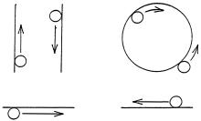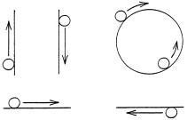

Tool center means no compensation either right or left. That is, the centerline of the tool will be moved to the programmed points.

Conrad (Connecting or Corner Radius)
Conrad is another really nice feature of the ProtoTRAK EMX. In the example below you could machine a straight line from Point A to B, then an ARC with radius R from B to D, then another straight line from D to E.
The problem is that the arc is not easy to program because you often don’t know where point D or B, or the center of R is located. However, you may know where Point C is, or you may be able to figure it out easily. In that case you can program the above part by programming a straight line from A to C, tell the control when it asks that you have a CONRAD equal to R, and then program another straight line from C to E. The ProtoTRAK will automatically blend the connecting radius (CONRAD R) between the two straight lines with no additional input.

For Rectangular Pockets or Frames, CONRAD stands for corner radius. You may input any value that makes sense considering the size of the pocket and the diameter of the tool.

Basic Operation
Take this manual out to the machine.

Turn the ProtoTRAK EMX On
If you don’t use the ProtoTRAK for 20 minutes, its screen will go blank. This is the screen saver. Press any key or turn the X or Y hand wheels and it will come on immediately.

Screen Organization
Almost every screen is organized like the one below and divided into four sections. The screen below will show a Z readout if purchased with that option.
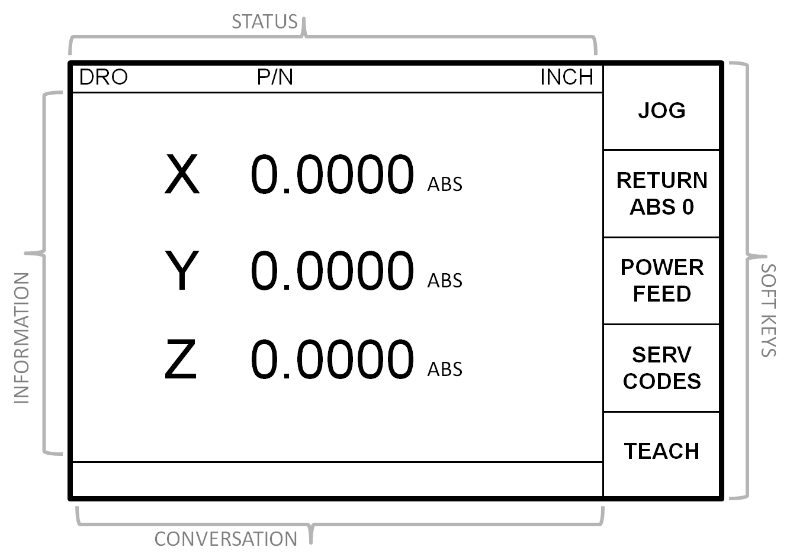

The STATUS line is on the top. It tells you what mode of operation you are in, whether you’re in inch or metric, if the servo motors are on, etc.

The INFORMATION area is below and is the largest part of the screen. It shows information or data depending on what you’re doing. In DRO operation it shows the axis readout; in Programming it shows the program; when you press LOOK in programming it shows a picture of your part, etc.

The CONVERSATION line is below the information area. This is probably the most important line because this is where you input all the data and this is where the ProtoTRAK will prompt you for the information or activity that it wants.

The SOFT KEY definitions are shown in the 5 boxes on the right. These explain the function of the 5 gray arrow keys directly to the right of each box. In this manual if we say press the JOG soft key, we mean press the gray arrow key to the right of the JOG box on the screen.

Keyboard Organization
The keyboard is made up of three sections: the soft keys, the data input keys, and the motion control keys.

The SOFT KEYS are the 5 unlabeled keys on the right side of the screen. Their function is defined by what is written on the screen in line with the key. If there is nothing written, then the key will not work.

The DATA INPUT keys are the number keys and the other keys close to them. The operation of these keys is pretty obvious or will be explained in the next section. One thing to note at this point is the difference between the INC SET and the ABS SET keys directly above the number keys. If you are inputting an X or Y dimension it is important to set or load this into the system with the correct key. If it is an absolute-referenced number, press ABS SET; if it is an incremental number, press INC SET. If you are inputting any value other than an X or Y, you may press either ABS SET or INC SET. In this case the manual will simply say SET.

The MOTION CONTROL keys are located to the upper right of the screen and consist of the GO, STOP and FEED keys. The FEED keys are the UP and DOWN arrows above and below, respectively, of the soft keys.

Modes
Press the MODE function key. The screen will show:
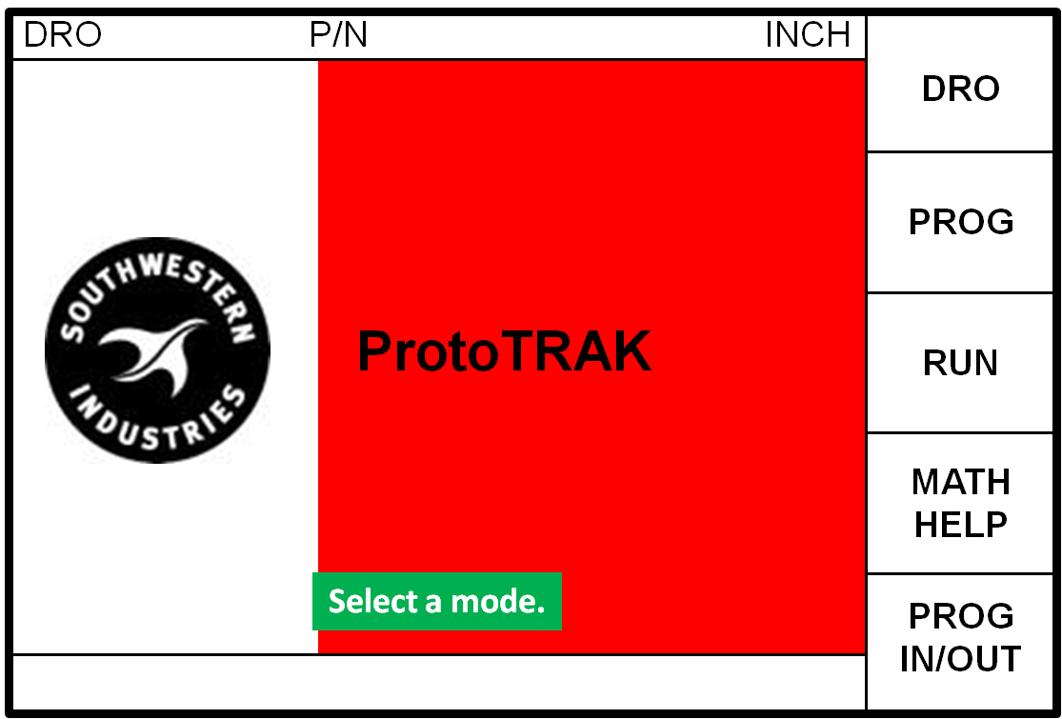
This is how you change from one mode of operation to another. After you press the MODE key, just press the soft key to the right of the box describing the mode of operation you wish. If you ever get confused just press MODE to get back to this beginning screen.

Manual Operation
Now press the DRO soft key from the Select Mode screen above. The screen will once again show:
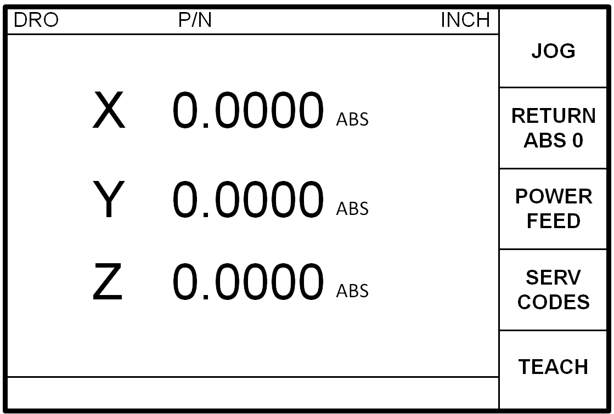
Do the following:
- Press X, ABS SET, Y, ABS SET, X INC SET, Y, INC SET. This will zero or reset the absolute and incremental readouts.
- Press the INC/ABS key above the 7 key. Notice the ABS on the screen changes to INC.
- Manually crank the X hand wheel so that the table moves left. Move the table so that the readout is X 1.0000 INC.
- Manually crank the Y hand wheel so that the saddle moves away from you. Move the saddle so that the readout is Y -1.0000 INC.
- Press X, INC SET and Y, INC SET to reset the X and Y incremental readout to zero.
- Move X another inch to 1.0000 INC and Y another inch to -1.0000 INC.
- Press the INC/ABS function key to show your absolute position. That is, how far you have moved from Step 1 above where you set absolute. X should read 2.0000 ABS, and Y -2.0000 ABS.
- Press X, ABS SET, Y, and ABS SET to reset absolute to the position you’re at now.

JOG
Do the following:
- Fold up the X and Y hand wheels (pull out, and then fold up).

WARNING
Never operate the ProtoTRAK under servo motor control unless the handles are
folded into their safety position.

- Press the JOG soft key. The conversation line will say “Feed rate 100”. This means the ProtoTRAK is ready to jog in the plus X or Y direction at 100 inches per minute (since you are in INCH mode).
- Press and hold X. The table moves to the left at 100 ipm. Release the X key to stop.
- Press and hold Y. The table moves towards you. Release.
- Press the +/- key. Notice the “Feed rate 100” in the conversation line changes to “Feed rate -100”.
- Press and hold X. The table now moves right. Release.
- Press and hold Y. The saddle now moves away. Release.
- Press the DOWN arrow key. Notice the “Feed rate -100” changes to “Feed rate -90”. Press the DOWN arrow key several more times.
- Press and hold X. Notice the table moves slower. Release.
- Press the UP arrow key several times until you are back to “Feed rate -100”
- Press number key 9 and ABS SET. Notice that the conversation line now says “Feed rate -9.0”. It took 9% of the current federate displayed.
- Press either X or Y. The table or saddle now moves at 9 ipm. This is the way to get low feed rates for power feeding straight cuts in X or Y.
- If you press the X or Y key on the DRO and simultaneously press the start button of the remote you can let go of the DRO button and the table will continue to move until you release the remote button.
- Press the RETURN soft key to exit jog operation and go back to manual.

Return to Absolute Zero
Do the following:
- Make sure the readout is displaying absolute (ABS). If not, press the INC/ABS key.
- Move the hand wheels to make sure you’re not at zero.
- Press the RETURN ABS 0 soft key.
- Press GO. The table and saddle will automatically move to the absolute zero you set earlier.

Teach
Teach allows you to machine a part by hand and command the ProtoTRAK EMX to remember the tool positions. This “taught” program can then be run for subsequent parts.
Imagine you have this simple job:
- Drill the 2 1/4 inch holes
- Mill 1/4 inch slot

- Set ABS 0 over the bottom left corner and make sure the table in X and Y is positioned so they are near the center of their travel.
- Press TEACH.
- Press INC/ABS (or not) to get into ABS readout.
- Using the hand wheels, move the table to X=1.0000 abs, Y=1.0000 abs. This is the position of the first hole.
- Press POSN DRILL.
- Move the table to X=2.0000 abs, Y=1.0000 abs. This is the second hole.
- Press POSN DRILL.
- Move the table to X=1.0000 abs, Y=2.0000 abs. This is the beginning of the slot.
- Press MILL BEGIN.
- Move the table to X=2.0000 abs, Y = 2.0000 abs. This is the end of the slot.
- Press MILL END.
- You have now “taught” the program.
- Press END TEACH. The events that you “taught” are now in the current program. To edit the events (which is required to select the tool numbers and set the feed rate of the mill event) press MODE and then PROG. To go to the beginning of the current program, press GO TO BEGIN.
- Press DELETE EVENT until TEACH POSN is the title of EVENT 1 (if there was no program already loaded, this will not have to be done).
- Press the DOWN ARROW until TOOL # is selected. Press ABS SET to give it the default number (or if you had a specific tool number, input it here).
- With the TOOL DIA selected, press ABS SET to give it the default value (since this a position event, no offsets are required).
- The second position event should now appear in the right window pane. Press the DOWN ARROW until TOOL # is highlighted. Press ABS SET. Press ABS SET again to give the TOOL DIA the default value.
- The mill event should now appear in the right window pane.
- Press the DOWN ARROW to select TOOL OFFSET.
- Press 0 for CENTER, ABS SET. You have now told the program that the programmed locations are for the center of the cutter.
- Press 6 to change the feed rate, and press ABS SET.
- Press 2, ABS SET to change the tool number.
- Press ABS SET again to give TOOL DIA the default value (since the OFFSET is CENTER, no actual offset will be calculated).
- Press 2, ABS SET to say that the mill event does not continue.
- You have now given the program enough information to run.
- Press MODE.
- Press RUN, START, and GO. The conversation line will tell you to load the specific tool number and to start the spindle. At this point, the X and Y hand wheels are under servo motor control and cannot be moved by hand.
- Press GO and the table will move to the first hole position and the conversation line will read “SET Z”. This is where you lower the quill in order to drill the desired hole.
- Press GO. The table moves to the second hole position.
- Pres GO. The table moves to the beginning of the slot. The conversation line will then prompt you to change your tool (this is where you load your end mill) and SET Z.
- Press GO. The table moves to the end of the slot at 6 inches per minute.
- Press GO and the conversation line will read RUN OVER at which point the CNC program has reached its end.
- Press MODE to exit out of the CNC mode and regain manual control over the X and Y hand wheels.

Sample Part 1
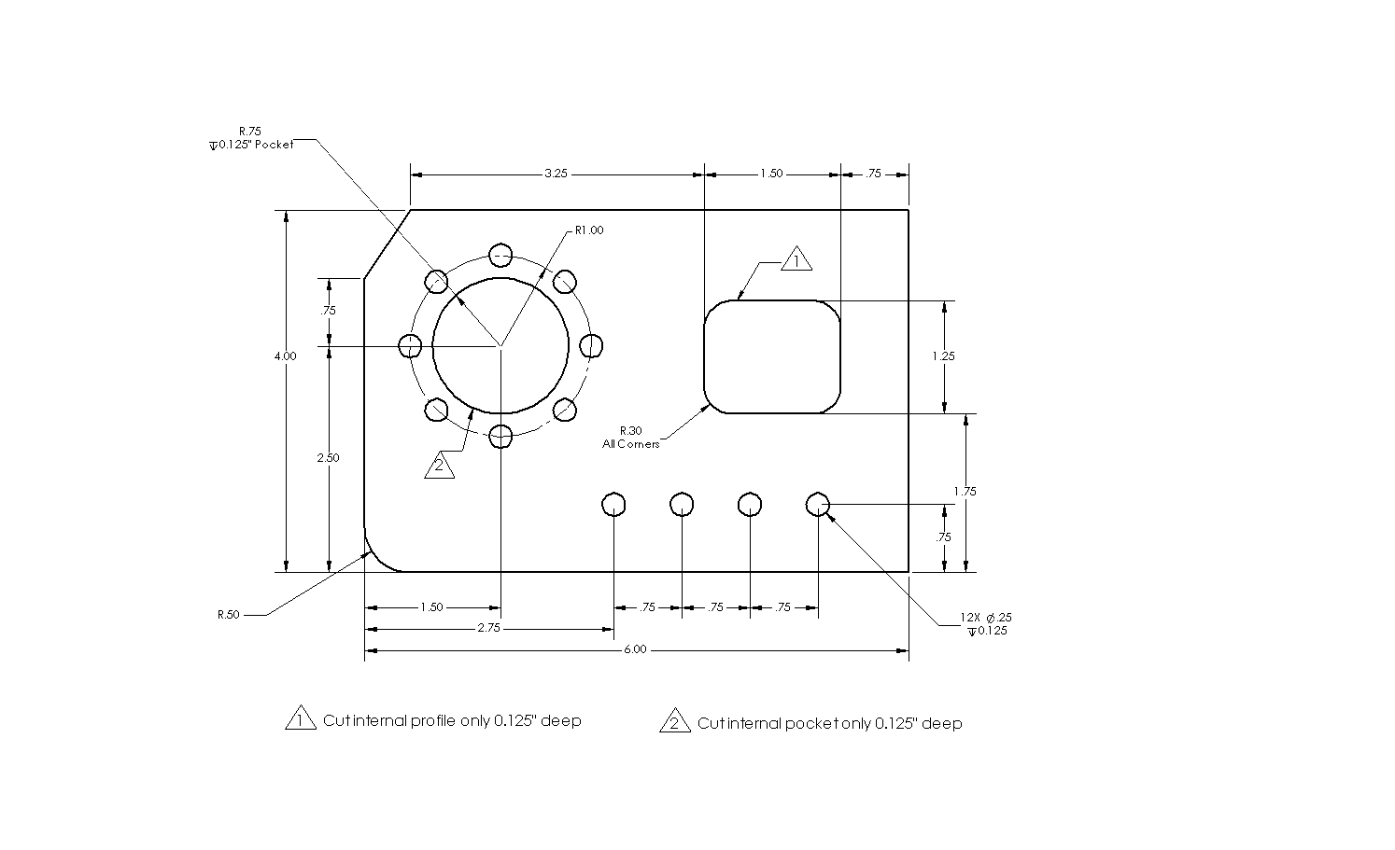
The purpose of this sample is to demonstrate most of the various event types or canned geometry’s that can be programmed. Also to give you practice inputting data and running an actual\

NOTE: It is always good practice to run your program with a tool loaded ABOVE the vise/part to verify that the tool will not hit the vise or mounting hardware.

Program Strategy
If you wish to place the part in the vise before programming consult section Set up the Part Reference. Before programming a part, it’s important to figure out what you want to do and what order you want to do it.

The strategy for programming a ProtoTRAK EMX is pretty straightforward:

- Identify the geometry you want to machine from the print
- Select it on the control
- Answer the questions

Our plan for Sample Part 1 is:
1. Decide that the lower left corner of the part will be our absolute zero or absolute reference and enter the absolute zero location.
2. Drill the left most hole in the row using a Drill Event.
3. Drill the next 3 holes using a Repeat Event.
4. Drill the 8-hole bolt circle pattern using a Bolt Hole Event.
5. Mill the diagonal in the upper left corner using a Mill Event.
6. Mill the arc in the lower left corner using an Arc Event.
7. Mill the circular pocket with a Pocket Event.
8. Mill the through rectangle with a Frame Event.

Making and Inputting the Program
Press MODE and then press PROG soft key to enter the Program Mode.

The Program Part Number
- The conversation display says, “Program Name”. Input 123, SET (INC SET or ABS SET). If there is a program already in the current memory, you can erase it by pressing Erase in the Prog In/Out Mode before entering the program number.

Event 1 – Center Drill the First Hole
- The conversation says, “Select an Event”. You press POSN/DRILL soft key. Now, press ONE to select the single hole.
- The right side of the information area shows that Event 1 is a Position/Drill and it lists what data is required. But keep your eye on the conversation line.
- Conversation says, “X END”. You press 2.75, ABS SET. Remember the lower left corner is our Absolute zero.
- “Y END”. You press .75, ABS SET.
- “TOOL #”. You press 1, ABS SET.
- Tool number 1 is the center drill, so diameter is not important, press ABS SET.

Event 2 – The Next 3 Holes
- “Select an Event”. You press the SUB soft key, and then the REPEAT soft key for Event 2 to make the next 3 holes in the row.
- Event 2 is a Repeat Event and the data needed is shown on the right of the information area. Notice Event 1 has shifted to the left.
- “First Event #”. You press 1, ABS SET because we want to repeat Event 1.
- “Last Event #”. You press 1, ABS SET because the only event we want to repeat is Event 1.
- “X Offset”. You press .75, INC SET because that’s the distance between the holes in the X direction.
- “Y Offset”. You press 0, INC SET because the other holes are not shifted in the Y direction.
- “# Repeats”. You press 3, ABS SET because we want 3 more holes each offset .75 inch.
- “Tool #”. You press 1, ABS SET because we’re using the same tool.
- "Tool Dia". You press ABS SET because we don't want to change the diameter for this tool.

Event 3 – The Bolt Hole Pattern
- “Select an Event.” You press POSN DRILL, then the BOLT HOLE soft key for Event 3.
- Event 2 has shifted to the left and the data you need to input is shown on the right.
- “# Holes”. You press 8, ABS SET because there are 8 holes.
- “X CENTER”. You press 1.5, ABS SET.
- “Y CENTER”. You press 2.5, ABS SET.
- “Radius”. You press 1., ABS SET because the radius of the bolt hole pattern is 1.000 inch.
- “Angle”. You press 90., ABS SET. This is the angle measured in the counterclockwise direction from 3:00 o’clock to the first hole you want to drill. We could have input 0 and then we would drill the right most hole first. Instead we are going to drill the top/highest hole first.
- “Tool #”. You press ABS SET. We’re still using tool number 1, but notice we didn’t press the 1. If you don’t input a number, the ProtoTRAK assumes the last tool is used again.
- "Tool Dia". You press ABS SET.

Event 4- Sub Repeat to drill holes after center drilling
- “Select an Event”. You press the SUB soft key, and then the REPEAT soft key for Event 4 to drill all the holes you have just center drilled.
- “First Event #”. You press 1, ABS SET because we want to repeat Event 1.
- “Last Event #”. You press 3, ABS SET because the only event we want to drill all the holes we have center drilled.
- “X Offset”. You press 0, INC SET because the holes to be drilled are in the same position.
- “Y Offset”. You press 0, INC SET because the other holes are not shifted in the Y direction.
- “# Repeats”. You press 1, ABS SET. If you wanted to countersink the holes you are drilling press 2, ABS SET. This would enable all the holes drilled to be immediately countersunk as well.
- “Tool #”. You press 2, ABS SET because we’re using a different tool.
- "Tool Dia". You press .25 ABS SET since the diameter of the drill bit is ¼.”

Event 5 – The Upper Left Diagonal
- “Select Event”. You press MILL soft key for Event 5.
- “X Begin”. You press 0, ABS SET to define the beginning of the milling cut at its lower left point on the diagonal.
- “Y Begin”. You press 3.25, ABS SET to define the beginning of the milling cut.
- “X End”. You press .5, ABS SET to define the end of the milling cut.
- “Y End”. You press .75, INC SET to define the end of the milling cut. Notice we defined this as an incremental change of .75 inch from the beginning. We could have also input 4.0, ABS SET to also define the end point. Think about this and make sure you understand.
- “CONRAD”. You press ABS SET because we don’t want to blend this mill cut into another cut.
- “Tool Offset”. You press 2, ABS SET because you’re selecting that the tool is to the left of the work piece as it moves from beginning to end.
- “Feed rate”. You press 5. , ABS SET to mill at 5 inches per minute.
- “Tool #”. You input 3, ABS SET because we’re calling the 3/8 end mill tool number 3.
- "Tool Dia." You press .375 ABS SET.
- “Continue”. You input 2, ABS SET because this is not continuous path milling.

Event 6 – The Lower Left Radius
- “Select Event”. You input soft key ARC for Event 6.
- “X Begin”. You input 0, ABS SET because we’re going to start at the top and mill down and to the right.
- “Y Begin”. You input .5, ABS SET.
- “X End”. You input .5, ABS SET.
- “Y End”. You input 0, ABS SET.
- “X Center”. You input .5, ABS SET, or we could have input 0, INC SET since the X Center is the same as the X End.
- “Y Center”. You input .5, ABS SET.
- “CONRAD”. You input 0, ABS SET.
- “Direction”. You input 2, ABS SET because we are milling in a counterclockwise direction.
- “Tool Offset”. You input 1, ABS SET because looking from beginning towards end (the direction of the tool cut) the tool is to the right of the work piece. Think about this to be sure you understand.
- “Feed rate”. You input 5., ABS SET.
- “Tool #”. You input 3, ABS SET because that’s still our tool.
- "Tool Dia". You input .375 ABS SET (or ABS SET).
- “Continue”. You input 2, ABS SET because this is not a continuous milling path.

Event 7 – The Circular Pocket
- “Select Event”. You press POCKET FRAME soft key for Event 7.
- “Select”. You press CIRCLE PCKT soft key because our pocket is circular.
- “X Center”. You press 1.5, ABS SET.
- “Y Center”. You press 2.5, ABS SET.
- “Radius”. You press .75, ABS SET defining the radius of the pocket.
- “Direction”. You press 1, ABS SET to select clockwise tool motion. We could have just as easily selected counterclockwise.
- “Fin Cut”. You press .02, ABS SET to select a finish cut of .020 inches. When machining, the program will hog out the pocket .020 undersized then make a finish cut pass to the proper size.
- “Feed rate”. You press 8., ABS SET.
- “Fin Feed rate”. You press 8., ABS SET (the finishing feed rate doesn’t have to be the same as the roughing feed rate).
- “Tool #”. You press ABS SET.
- "Tool Dia". You press ABS SET.

Event 8 – The Through Rectangle
- “Select Event”. You press POCKET FRAME soft key for Event 8.
- “Select”. You press RECT PROFILE soft key for the rectangular frame.
- “X1”. You press 3.75, ABS SET which is the distance to corner number 1, which we will say is the lower left corner of the frame.
- “Y1”. You press 1.75, ABS SET.
- “X 3”. You press 1.5, INC SET because corner number 3 is the diagonal corner and it is 1.5 inches in the plus X direction from X1.
- “Y3”. You press 1.25, INC SET.
- “CONRAD”. You press .3, ABS SET because the corner radius of the frame is .300 inch.
- “Direction”. You press 2, ABS SET to choose counterclockwise.
- “Tool Offset.” You press 2, ABS SET because when the tool moves counterclockwise around the inside of the rectangle frame, it is to the left of the work piece.
- “Fin Cut”. You press .03, ABS SET to select a .030 inch finish cut.
- “Feed rate.” You press 5., ABS SET.
- “Fin Feed rate.” You press 5., ABS SET.
- “Tool #”. You press ABS SET because we’re still using tool number 3.
- "Tool Dia". You press ABS SET.

Look at the Program
- Press the LOOK hard key to see what your program looks like. You don't have to finish the programming to see what you've done so far. Any time you see the SELECT EVENT prompt in the Program Mode, you can look at the part graphics.

The drawn part should look like this:
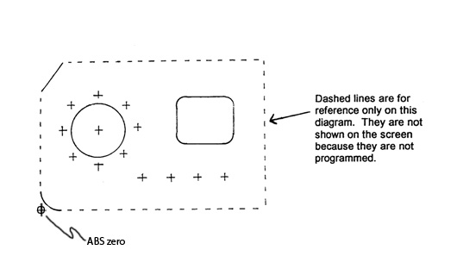

If your part draw doesn’t look like this, don’t panic. See if you can figure out what piece of geometry, and therefore what event looks wrong. Go back to that part of your program and check your inputs against these instructions.

If the ProtoTRAK refused to draw your part and indicated a data error, read the explanation and solution and it will suggest the way to resolve the problem.
- Press RETURN. The program is complete

Program In/Out Mode
Now that we have a good program we want to save it. If you turn the ProtoTRAK off now the program will be lost. To prevent this, we will save it on the system’s hard drive where it will stay (even without power) until you consciously erase it.

Do the following:

1. Press the MODE and select the PROG IN/OUT soft key.
2. Put in a part number you will remember at this time. You press SAVE soft key and wait a few seconds until it’s complete. Notice your new part number is now in the list.
3. Also notice that the current program name is listed at the top of the screen in the status bar.

Program Run Preparation

Setup the Work piece
Take a piece of 6” x 4” x 3/8” HDPE and lock it into the vise as shown below. Use step jaws or parallels. Make sure the material sticks out to the left of the vise by about 1 1/2 inches.

Set up the Part Reference
- Press MODE and select DRO soft key.
- Press INC/ABS to be sure the display reads the absolute position (ABS).
- X and Y ABS SET should be used to zero the DRO. Use the edge finder to position the center of the spindle over the lower left corner of your part. Run the edge finder at 600 – 800 rpms.
- The read out should display X 0.0000 ABS and Y 0.0000 ABS when the spindle is over the lower left corner.

Program Run

NOTE: It is always good practice to run your program with a tool loaded ABOVE the vise/part to verify that the tool will not hit the vise or mounting hardware.

This is where we make the part. Do the following:

Enter the Run Mode
- Press MODE and select RUN soft key.
- The conversation line says, “Select”. You press START soft key. The START EVENT # soft key allows you to start in the middle of a program, but we don’t want to do that.
- Press GO, and the saddle will move to the first hole location.

Center Drill the Holes
- “Load Tool 1”. You should load the center drill in the spindle, then start the spindle, and adjust the RPM.
- X and Y readouts should read zero ABS. Beneath them the actual federate (now zero), and the feed rate override percent (now 100%) are shown.
- Press GO. The tool will move (actually the table moves) to the first hole in the row.
- “Set Z”. You move the quill and center drill the hole. After every drilling operation always make sure the tool is up to clear the work piece.
- Press GO and drill the remaining holes and in the bolt hole pattern each time the conversation line says “Set Z”.

Drill the Holes
- “Load Tool 2 Dia .25” You should load the .25” Drill in the chuck, then start the spindle, and adjust the RPM.
- Press GO. The tool will move (actually the table moves) to the first hole in the row.
- “Set Z”. You move the quill and drill the hole to a depth of 0.125”. After every drilling operation always make sure the tool is up to clear the work piece.
- Press GO and drill the remaining holes and in the bolt hole pattern each time the conversation line says “Set Z”.

Mill the Upper Left Diagonal
- When the last hole is drilled the conversation line says, “Load Tool 3 Dia .375”. You should stop the spindle, load the 3/8 end mill, start the spindle and adjust the RPM.
- Press GO. The tool will move to the upper left edge of the part where the diagonal cut begins.
- “Set Z”. You move the quill so the tool is 0.125” below the top of the work piece. Do this by setting the quill stop within 1-2” of the top, bring the quill down on top of the stop, and lock the quill at this position. Touch off the end mill on top of the piece by making a chip. Set the Z to 0, and then move the Z axis until you are -.125”.
- Press GO. The tool will move at 5 ipm and cut the diagonal.
- “Check Z”. This is a warning to raise the quill because the next move will be at rapid speed (100 ipm). You should raise the tool.

Mill the Lower Left Radius
- Press GO. The tool will rapid to the beginning position for the Arc cut.
- “Set Z”. Lower the tool to 0.125” and lock the quill.
- Press GO. The tool will move at 5 ipm and cut the arc.
- “Check Z”. You should raise the tool.

Mill the Circular Pocket
- Press GO. The tool will rapid to about the center of the pocket.
- “Set Z.” Bring the tool down (or the knee up) to .125” below the top of the part and lock the quill.
- Press GO. The tool will move at 8 ipm to machine the pocket. Press the FEED ­ and FEED + keys while cutting the pocket to see how you can adjust the speed while you’re cutting. When the pocket is roughed out a little undersized, the cutter will automatically make the program .020 finish cut.
- “Check Z”. You should raise the tool.

Mill the Rectangle
- Press GO. The tool will rapidly move to the beginning point to machine the rectangular frame thru.
- “Set Z”. Move the quill down so that the tool is 0.125” below the top of the piece. Lock the quill.
- Press GO. The tool will move at 5 ipm (if you left the feed rate override at 100% when you adjusted FEED ­ and FEED ¯ ) to machine the rectangle and make the finish pass.
- “Run Over”. The part is finished. If you were making a second part and could locate it in the vise in the same place, you could now press the NEXT PART soft key and the whole program would be repeated.
- Press MODE to exit Run. Congratulations. You made your first part!

